COER UNIVERSITY, ROORKEE
Department of Computer Science & Engineering
Full Stack Web Development
Class Test
NAME :- Dev Sharma
Cu24250269
BTech cse “A”
Roll no. 17
Q1. Node.js — The Event Loop
Question
Predict the exact console output order for the given code and justify the answer.
console.log('A');
setTimeout(() => console.log('B'), 0);
Promise.resolve().then(() => console.log('C'));
console.log('D');
Q2. Node.js — Modules
calc.js
function add(a, b) {
return a + b; }
function subtract(a, b) {
return a - b; }
module.exports = {
add,
subtract };
app.js
const { add, subtract } = require('./calc');
console.log(add(4, 5));
Q3. Express.js — Middleware & Routing
server.js
const express = require('express');
const app = express();
const PORT = 5000;
app.use(express.json());
function requireAuth(req, res, next) {
if (req.headers['x-api-key'] !== 'secret123') {
return res.status(401).json({
error: 'Unauthorized' }); }
next(); }
app.get('/api/books', (req, res) => {
res.json([
{ id: 1, title: 'Node.js Basics' },
{ id: 2, title: 'Express Guide' }
]); });
app.post('/api/books', requireAuth, (req, res) => {
res.status(201).json({
message: 'Book created',
book: req.body }); });
app.listen(PORT, () => {
console.log(`Server running on http://localhost:${PORT}`); });
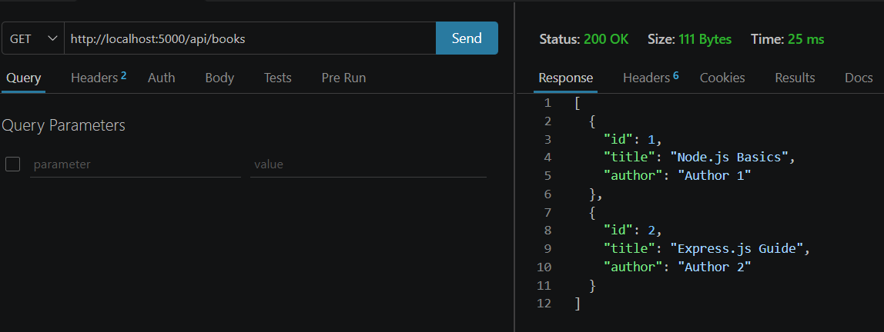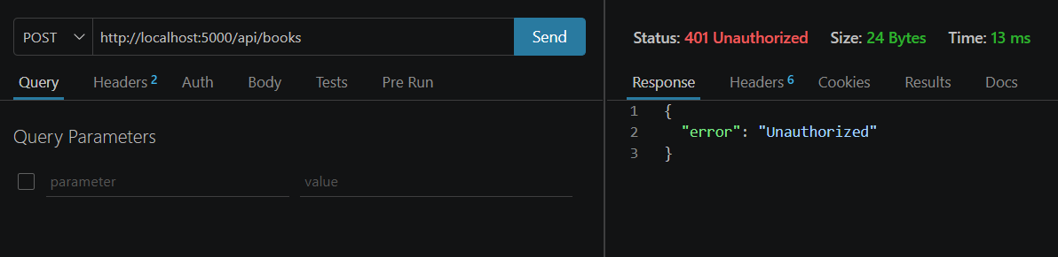
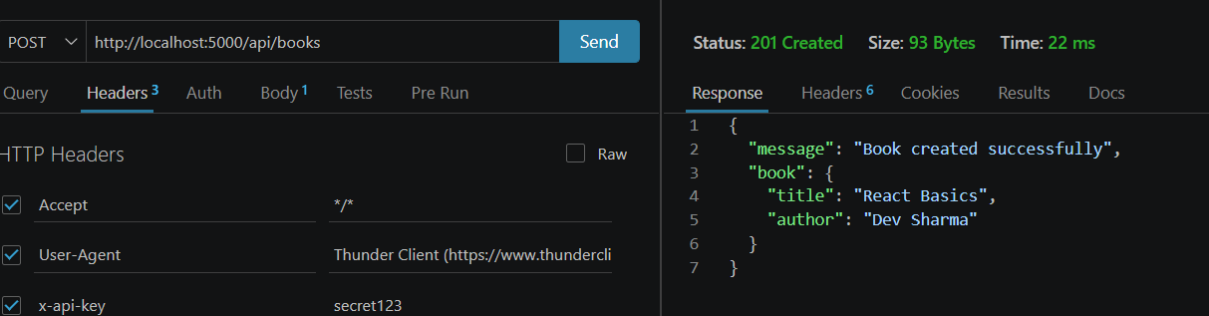
Q4. Express.js — Building a REST API
server.js
const express = require('express');
const app = express();
const PORT = 5000;
app.use(express.json());
let books = [ {
id: 1,
title: 'Node.js Basics',
author: 'Dev sharma' }, {
id: 2,
title: 'Express Guide',
author: 'Riya shukla' } ];
app.get('/api/books', (req, res) => {
res.status(200).json(books); });
app.post('/api/books', (req, res) => {
const { title, author } = req.body;
const newBook = {
id: books.length + 1,
title,
author };
books.push(newBook);
res.status(201).json(newBook); });
app.delete('/api/books/:id', (req, res) => {
const id = Number(req.params.id);
const index = books.findIndex(book => book.id === id);
if (index === -1) {
return res.status(404).json({
error: 'Book not found' }); }
const deletedBook = books.splice(index, 1);
res.status(200).json({
message: 'Book deleted',
book: deletedBook[0] }); });
app.listen(PORT, () => {
console.log(`Server running on http://localhost:${PORT}`);
});
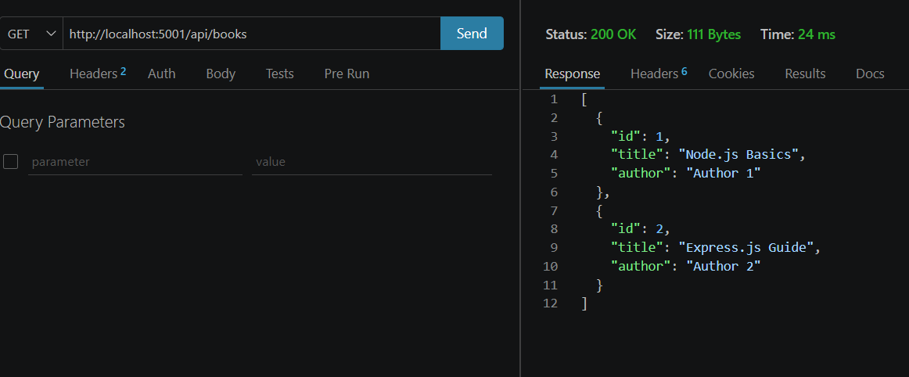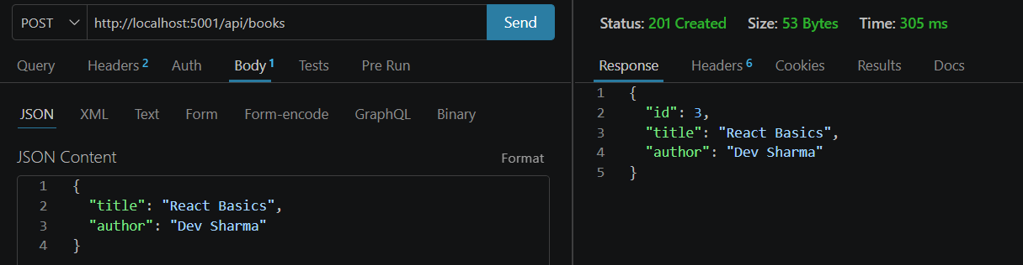
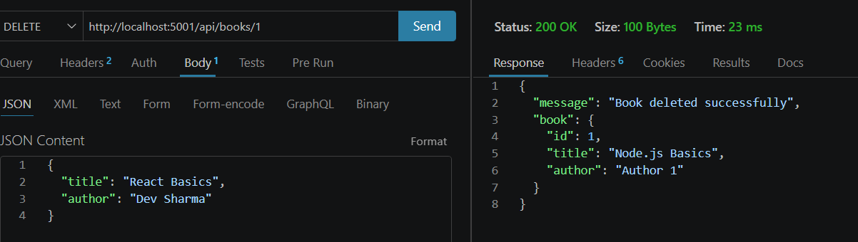
Q5. Express.js — Debugging & Error Handling
Problem
The original code is:
app.get('/api/books/:id', (req, res) => {
const book = books.find(b => b.id == req.params.id);
res.json(book.title); });
Bug
If the requested book does not exist, book becomes undefined. Therefore: book.title causes an error.
Correct Code
app.get('/api/books/:id', (req, res) => {
const book = books.find(b => b.id == req.params.id);
if (!book) {
return res.status(404).json({
error: 'Book not found' }); }
res.json(book.title);
});
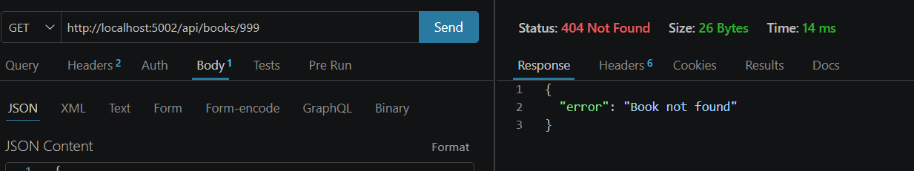
Q6. APIs — Consuming a REST API in React
BookList.jsx
import React, { useEffect, useState } from 'react';
function BookList() {
const [books, setBooks] = useState([]);
const [loading, setLoading] = useState(true);
const [error, setError] = useState('');
useEffect(() => {
fetch('http://localhost:5000/api/books')
.then(response => {
if (!response.ok) {
throw new Error('Failed to fetch books'); }
return response.json(); })
.then(data => {
setBooks(data);
setLoading(false); })
.catch(error => {
setError(error.message);
setLoading(false); }); }, []);
if (loading) {
return <h2>Loading...</h2>; }
if (error) {
return <h2>Error: {error}</h2>; }
return (
<div>
<h1>Book List</h1>
{books.map(book => (
<div key={book.id}>
<h3>{book.title}</h3>
<p>{book.author}</p>
</div> ))} </div> );}
export default BookList;
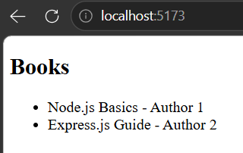

Q7. APIs — CORS
CORS (Cross-Origin Resource Sharing) is enforced by the browser, so a React app running on http://localhost:3000 cannot read responses from an Express API at http://localhost:5000 unless the API allows that origin. Postman is not a browser, so it does not enforce CORS in the same way.
const express = require('express');
const cors = require('cors');
const app = express();
// Allow the React app running on localhost:3000 to call this API.
app.use(cors({ origin: 'http://localhost:3000' }));
app.use(express.json());
app.get('/api/books', (req, res) => {
res.json([
{ id: 1, title: 'Node.js Basics', author: 'Author 1' },
{ id: 2, title: 'Express.js Guide', author: 'Author 2' }
]);
});
app.listen(5000, () => {
console.log('Q7 server running on http://localhost:5000');
});

